Engineering Bulletin
DC-EB-0593 - Foxbat 2.x-2N MV Load Bank Cut-In |  | Sub Type | CAB
 |  | Date | Feb 10, 2026
 |  | ECM Bug | b/468311552
Author | apoletto@, adamhorton@
Region | North America | Cost Bug | b/477564532
Focus Area | ​ | A/E Design Scope | Yes
Discipline | Electrical
Included in Canonical? | None
Sites | ADC2A, ADC3A, ADC4A, ADC5A, ARA3A, ARO1A, CFC1A, CFC2A, CFC3A, CLB4A, CLB5A, CLB6A, CYL1A, CYL2A, EWD2A, EWD3A, EWD4A, EWD5A, GOR2A, GVO1A, HJS1A, HRF1A, HRF2A, JRN1A, JRN2A, JUR1A, KNC1A, KNC3A, KNC4A, KWR1A, LCT3A, LMA1A, LMA2A, LNR4A, MDN3B, MDN5A, MDN6A, MDN7A, MNK10A, MNK9A, MNO1A, MNO2A, MOS1A, MSA2A, MSA3A, MUS1A, MUS2A, MUS3A, NBF2A, NBF3A, NBF4A, NBY7A, NOL1A, NRD1A, NRD2A, NRD3A, NRD4A, PMH1A, PRL2A, QST1A, RLF4A, RWO1A, SBP3A, SGR1A, SGR2A, SKW1A, SLN6A, SLN7A, SLN8A, SML2A, SRP5A, SRP6A, STY4A, SWR1A, SWR2A, THM1A, THM2A, THM3A, THM4A, THM5A, UNO3A, UNO4A, UNO5A, UNO6A, VCN1A, VMY1A, WCK3A, WCK4A, WCP1A, WMS1A, WMS2A, WMS3A, WSB1A, WSB2A

Change Log

Executive Summary:
The load bank strategy for Foxbat 2.x US generator paralleling switchgear has transitioned from a temporary rental model to a permanently installed solution.

In Scope:
- All existing, in-flight, and future Foxbat 2.x US projects with medium voltage generators connected to a generator parallelling switchgear are in scope.
Impact:
- Design: A/E documents must be updated and re-issued to reflect permanent integration.
- Procurement: Additional ONCP (owner-negotiated, contractor-procured) hardware is required.
- Construction: The Contractor SOW shall be expanded to include all associated mechanical and electrical installation requirements for the permanent unit.
Background:
The existing FB2 design includes a medium voltage dead-break elbow below each Generator Paralleling System (GPS) Switchgear for connection of a portable medium voltage load bank. For each load bank application, a rental step-down transformer and rental low voltage load bank would be procured, connected, and operated.

After an escalation process through DCOPs and DCTS management, the short term solution is to mandate the installation of a permanent, off the shelf, combination step-down transformer and load bank connected to every two GPS.

Site Selection Criteria:
All in-flight Foxbat 2.X US projects with medium voltage generators connected to a generator parallelling switchgear are in scope.

Details and Required Actions:

The site team shall evaluate project status to align on feasibility of a permanently installed load bank in alignment with project schedule to accommodate the following:
- A/E to update design drawings per redlines below to account for procurement and installation of skidded step-down transformer and load bank.
- GC to procure and install load bank per updated design drawings.

Scope of work:
  - Procure a skid mounted transformer / loadbank ( Atron model 9830)
    - 13.8KV - 480V - 3MVA Transformer
    - 480V / 3MVA Loadbank with air cooling provisions
    - Manual loadbank controls
    - Low Side fused protection for power and control components
    - Contact Info:
      - Justin Leon
      - Business Development Manager-Data Centers
      - E Justin.Leon@avtronpower.com
      - M 219 796 6151

  - Install the skid in a central location in the EYD, ideally between the two GPS switchgear. The exact location shall be coordinated with the local DCOps team, considering minimal MV feeder routing, available space for LB.

  - Install conveyance and connect MV Cables from the Zone 1 and Zone 2 GPS 52LB (Load Bank) breaker to the primary side of the transformer
    - There will be two feeds to the skid, one from each GPS.
    - Provide MV Cables / Terms to match like equipment on the site and sized for 3MVA
      - Conductor: (1) 3-1/C - 2/0 AWG Cu 15kV, 133%, EPR, TS & (1) 4/0 AWG XHHW-2 CU EGC
      - Load Bank Terminations: Lugs and MV termination kit.
      - GPS Terminations: The canonical foxbat 2 design drawings indicate a separable connector dead-break intended portable, medium voltage load bank hook-up.
        - If the separable connectors are already installed, terminate the new cable to matching separable connectors and connect them for permanent install.
        - If the separable connectors and MV cable to the GPS 52LB are not installed yet, evaluate omitting them from the design and directly connect the new LB MV conductor to the GPS switchgear via lugs and medium voltage termination kit.

  - Kirk key electrical interlock installation
    - The two MV cables will parallel the two GPS switchgear at the transformers primary termination point, however, the equipment will not operate paralleled.
    - A kirk key interlock system shall be installed on each GPS 52LB feeder feeder to inhibit the paralleling of the two GPS switchgear. Coordinate installation with the respective equipment vendor.
    - The kirk system will allow only (1) breaker to be racked in at a time
    - The unused breaker will remain racked out and open

  - SCCAF
    - Primary protection should be provided by the GPS and new relay settings provided
    - Secondary protection should be provided internally by the load bank
    - Proper coordination should be achieved
    - Arc flash labels shall be applied

Brown-Field Cut-in (Design has progressed far enough that separable connector is in place or planning/materials and such are substantially complete):

Drawing EG-500.01.1 - Electrical Single Line Diagram Power Phase 1 (and other relevant single lines)
- Add skidded Step-down transformer + Load bank
- Add key interlock at GPS-1
- Add MV cable to XFMR+LB
- Add separable connector termination
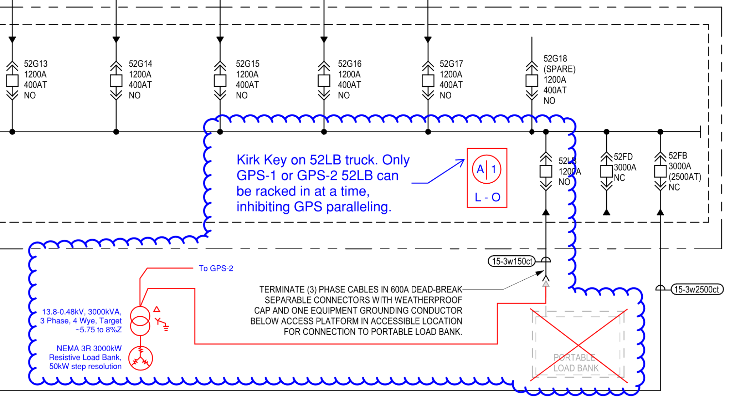

Drawing EG-500.01.2 - Electrical Single Line Diagram Power Phase 2 (and other relevant single lines)
- Add key interlock at GPS-2
- Add MV cable to XFMR+LB
- Add separable connector termination
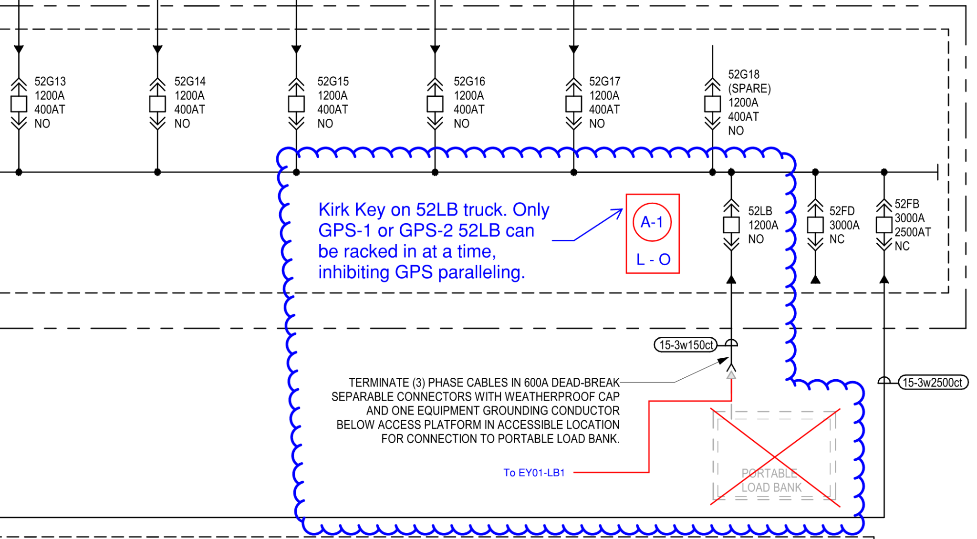

Drawing 1A.2-E-250C (and other plan views)
- Add skidded Step-down transformer + Load bank:
- Add MV conveyance and feeder from GPS-1 and GPS-2 to XFMR.
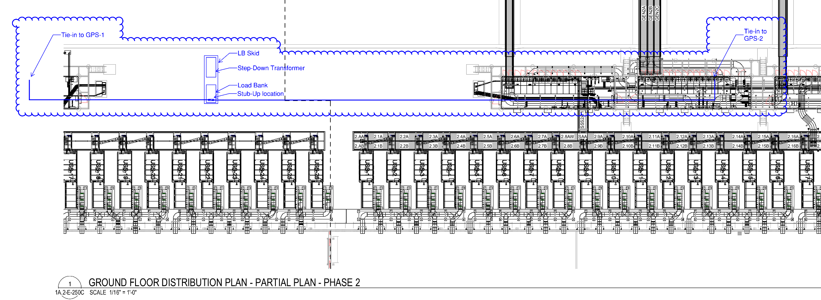

Green-Field Cut-in (Early in Design):

Drawing EG-500.01.1 - Electrical Single Line Diagram Power Phase 1 (and other relevant single lines)
- Add skidded Step-down transformer + Load bank
- Add key interlock at GPS-1
- Add MV cable to XFMR+LB
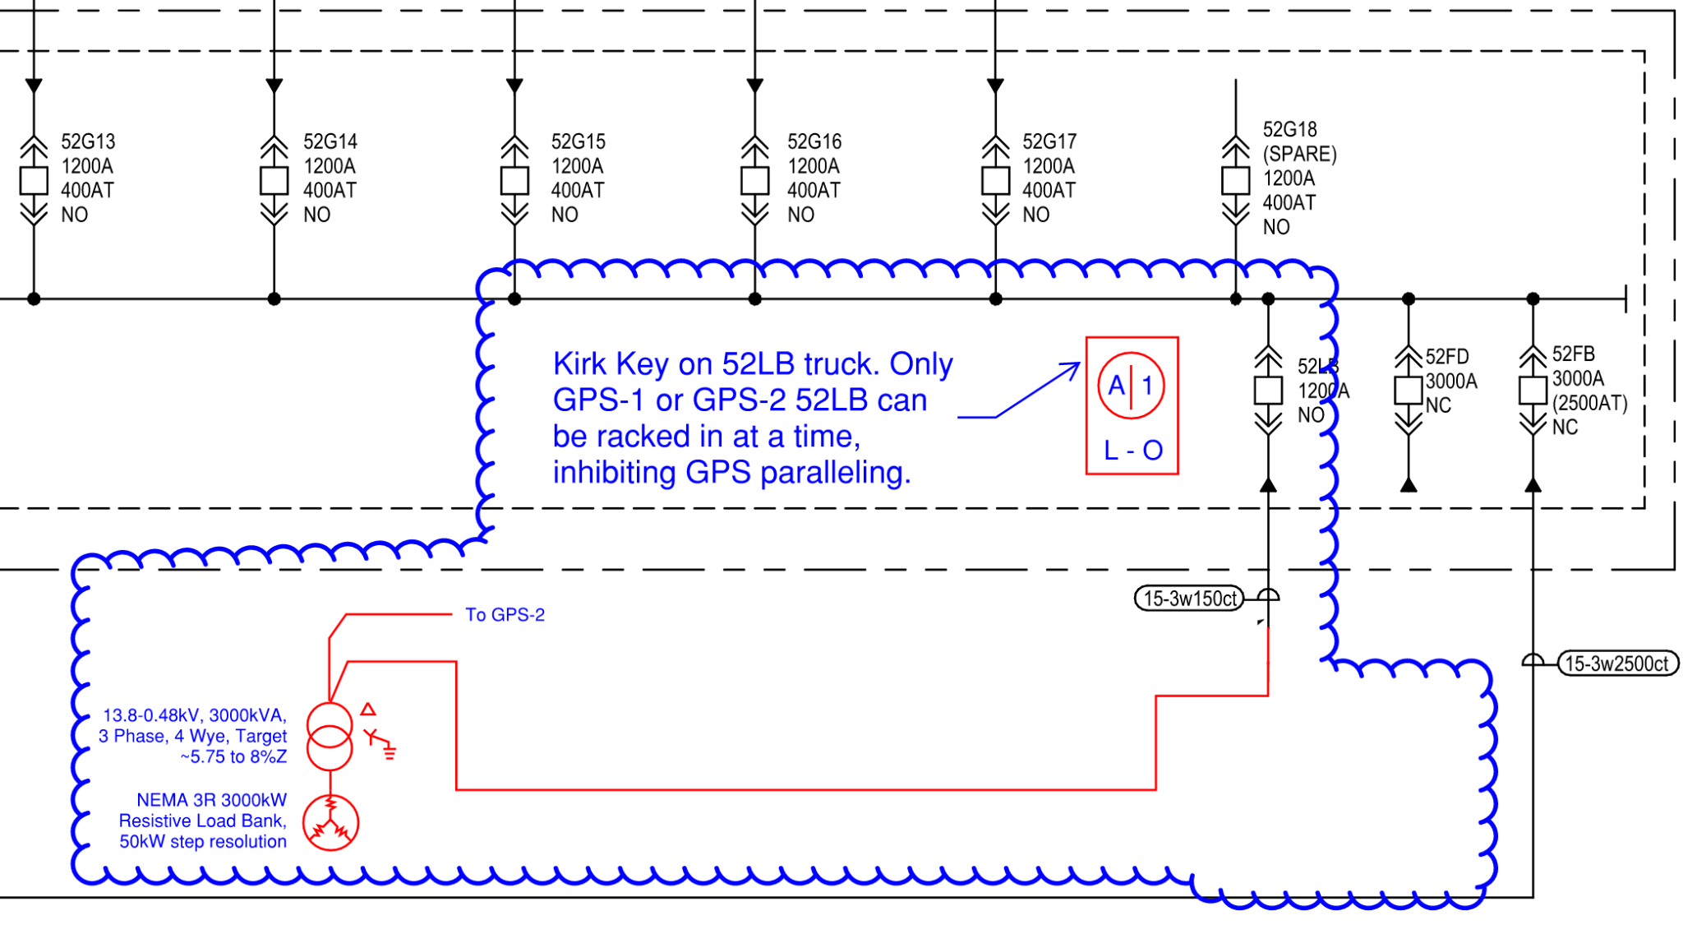
Drawing EG-500.01.2 - Electrical Single Line Diagram Power Phase 2 (and other relevant single lines)
- Add key interlock at GPS-2
- Add MV cable to XFMR+LB

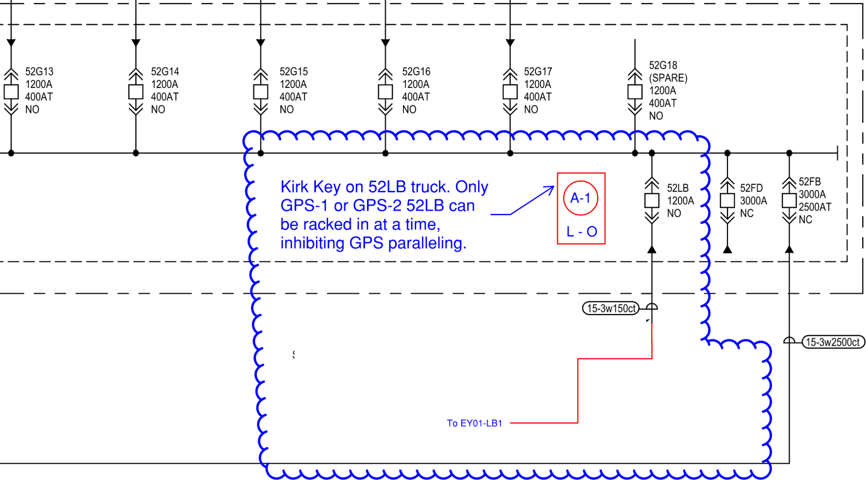

Drawing 1A.2-E-250C (and other plan views)
- Add skidded Step-down transformer + Load bank:
- Add MV conveyance and feeder from GPS-1 and GPS-2 to XFMR.

Reference information:
- The product basis of design is an Avtron skidded transformer+load bank Model 9830 Outdoor Resistive Load Bank, Catalog number 983030004AD1A10X,R1A,R16A3. Power for the load bank fans is self-derived, the medium voltage cable is the only connection.

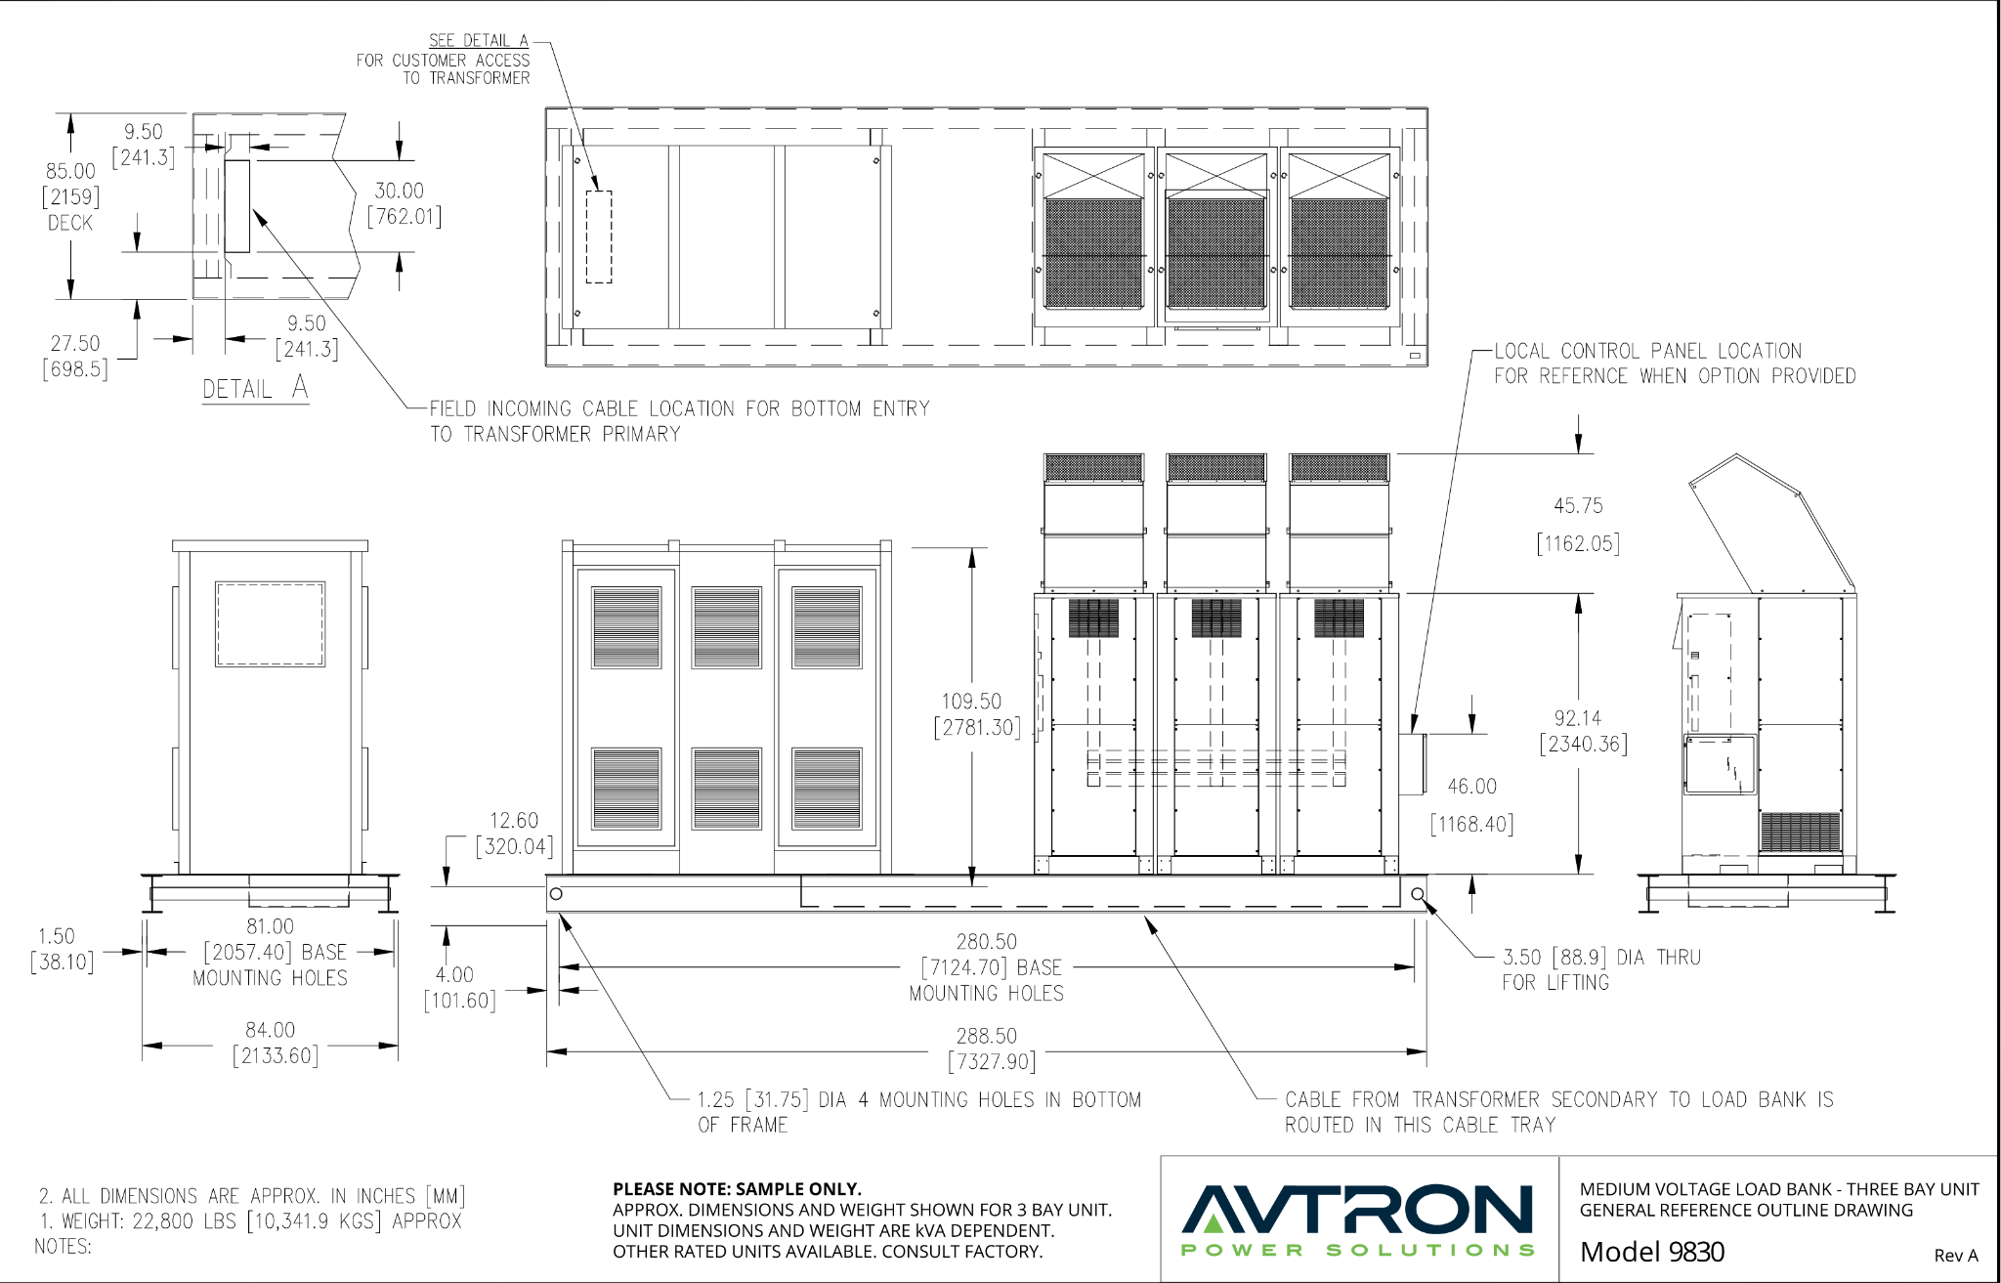

BIM Narrative:

The BIM model is not required to make these changes. The EOR shall review the pdf sheets baked on the revised drawing numbers noted in the “Details” section above and edit the existing project sheets to match.

Document(s)
Title | UID | Revision
DWG - EA - FOX - Avtron Model 9830 Outline Drawing - 448878825__70636557__425038 - v1 - Released | 135448 | 1
DWG - EA - FOX - Brownfield - EG-500.01.1 & EG-500.01.2 - Pages from DWG - EA - FOX - v1 - Released | 135447 | 1
DWG - EA - FOX - Greenfield & Brownfield - 1A.2-E-250C - Pages from DWG - EA - FOX - v1 - Released | 135449 | 1
DWG - EA - FOX - Avtron Model 9800 Series Data Sheet - 448878825__70636497__425038 - v1 - Released | 135446 | 1
DWG - EA - FOX - Greenfield - EG-500.01.1 & EG-500.01.2 - Pages from DWG - EA - FOX - v1 - Released | 135450 | 1

END OF BULLETIN


